**4.1 PROGRAMS:**

**IF ELSIF ELSE CLAUSE:**

DECLARE

v_myage NUMBER := 31;

BEGIN

IF v_myage < 11 THEN

DBMS_OUTPUT.PUT_LINE('I am a child');

ELSIF v_myage < 20 THEN

DBMS_OUTPUT.PUT_LINE('I am young');

ELSIF v_myage < 30 THEN

DBMS_OUTPUT.PUT_LINE('I am in my twenties');

ELSIF v_myage < 40 THEN

DBMS_OUTPUT.PUT_LINE('I am in my thirties');

ELSE

DBMS_OUTPUT.PUT_LINE('I am mature');

END IF;

END;



**IF AND ELSE CLAUSE:**

DECLARE

v_myage NUMBER := 31;

BEGIN

IF v_myage < 11 THEN

DBMS_OUTPUT.PUT_LINE('I am a child');

ELSE

DBMS_OUTPUT.PUT_LINE('I am not a child');

END IF;

END;



DECLARE

v_myage NUMBER := 31;

BEGIN

IF v_myage < 11 THEN

DBMS_OUTPUT.PUT_LINE('I am a child');

END IF;

END;

**(4.2)CASE STATEMENT:**

DECLARE

v_num NUMBER := 15;

v_txt VARCHAR2(50);

BEGIN

CASE v_num

WHEN 20 THEN v_txt := 'number equals 20';

WHEN 17 THEN v_txt := 'number equals 17';

WHEN 15 THEN v_txt := 'number equals 15';

WHEN 13 THEN v_txt := 'number equals 13';

WHEN 10 THEN v_txt := 'number equals 10';

ELSE v_txt := 'some other number';

END CASE;

DBMS_OUTPUT.PUT_LINE(v_txt);

END;



CASE STATEMENT:

DECLARE

v_grade CHAR(1) := 'A';

v_appraisal VARCHAR2(20);

BEGIN

v_appraisal :=

CASE

WHEN v_grade = 'A' THEN 'Excellent'

WHEN v_grade IN ('B','C') THEN 'Good'

ELSE 'No such grade'

END;

DBMS_OUTPUT.PUT_LINE ('Grade: '|| v_grade || ' Appraisal '

|| v_appraisal);

END;



**(4.3)**

**EXIT STATEMENT:**

DECLARE

v_counter NUMBER := 1;

BEGIN

LOOP

DBMS_OUTPUT.PUT_LINE('Counter is ' || v_counter);

v_counter := v_counter + 1;

IF v_counter > 10 THEN EXIT;

END IF;

END LOOP;

END;

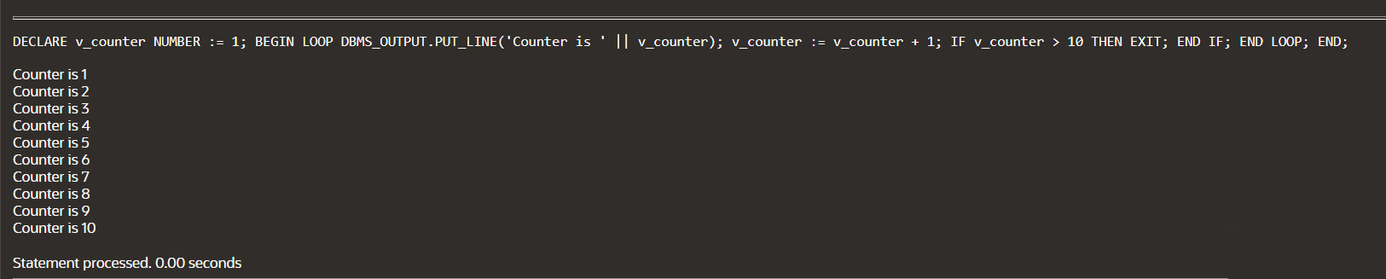

**EXIT WHEN STATEMENT:**

DECLARE

v_counter NUMBER := 1;

BEGIN

LOOP

DBMS_OUTPUT.PUT_LINE('Counter is ' || v_counter);

v_counter := v_counter + 1;

EXIT WHEN v_counter > 10;

END LOOP;

END;

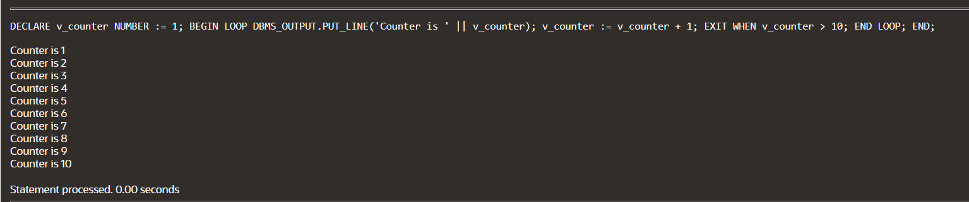

WHILE LOOP:

DECLARE

v_DEPARTMENT_ID PERSON2.DEPARTMENT_ID%TYPE;

v_counter NUMBER := 1;

BEGIN

SELECT MAX(DEPARTMENT_ID) INTO v_DEPARTMENT_ID FROM PERSON2

WHERE DOB = 2006;

WHILE v_counter <= 3 LOOP

INSERT INTO PERSON2(DEPARTMENT_ID, LAST_NAME, DOB)

VALUES((v_DEPARTMENT_ID + v_counter), 'PRIYADARSHINI', 2006);

v_counter := v_counter + 1;

END LOOP;

END;

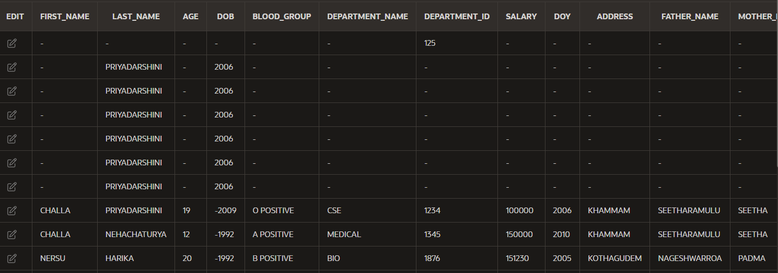

FOR LOOP:

DECLARE

v_DEPARTMENT_ID PERSON2.DEPARTMENT_ID%TYPE;

BEGIN

SELECT MAX(DEPARTMENT_ID) INTO v_DEPARTMENT_ID FROM PERSON2

WHERE DOB = 2006;

FOR i IN 1..2 LOOP

INSERT INTO PERSON2(DEPARTMENT_ID,LAST_NAME,DOB)

VALUES((v_DEPARTMENT_ID + i), 'NEHACHATURYA', 2010);

END LOOP;

END;

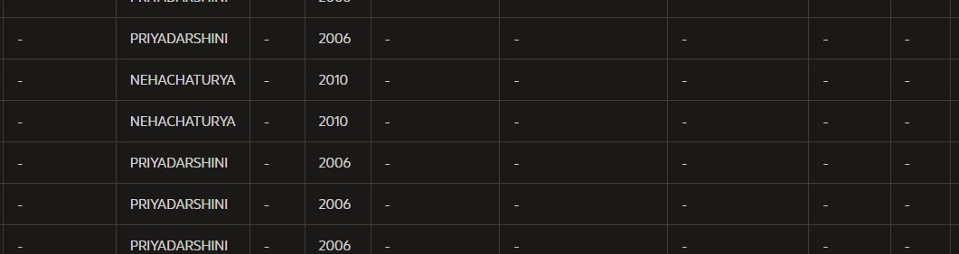

**NESTED LOOP:**

BEGIN

FOR v_outerloop IN 1..3 LOOP

FOR v_innerloop IN REVERSE 1..5 LOOP

DBMS_OUTPUT.PUT_LINE('Outer loop is: ' ||

v_outerloop ||

' and inner loop is: ' ||

v_innerloop);

END LOOP;

END LOOP;

END;

